Table of Contents
No table of contents entries found.

Implementation

The introduction starts with describing the purpose of this document and what it will cover.

1.1 Choice of Tools

In this section you should describe the tools you used to develop the application and why the specific choices were made, e.g. Visual Studio 2022, SQL Server 2019, etc. In each case use the name of the tool as a numbered sub-heading.

1.1.1 Visual Studio 2022

Discussion here.

1.1.2 SQL Server 2019

Discussion here.

1.2 Extracts of complex code

This section should present extracts of code which you found to be complex to write. This
needs to be your own code. Not code sourced from elsewhere. Think about things that happen in your system that might be different to what is found in other student’s systems. For each code extract, provide a descriptive overview of what happens in the piece of code.

Example:

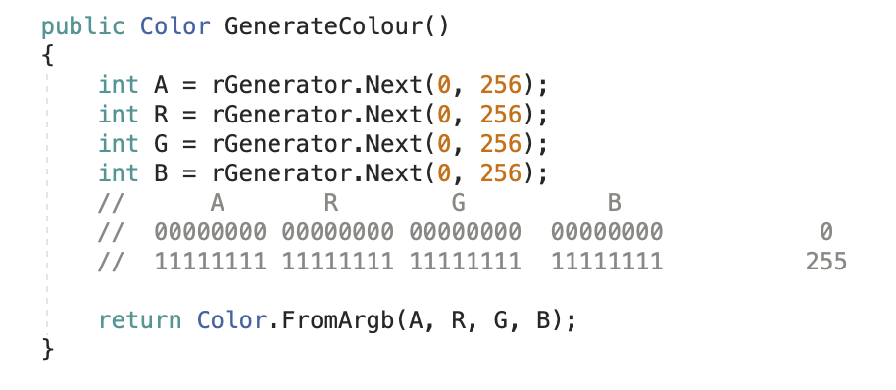
Figure 1.2 A method for generating a colour
The GenerateColour method is used to randomly generate colours. It makes use of a Random number generator object (rGenerator) which has been declared static in another section of the application. The method generates 4 values in the range 0 to 255, which are then used to create a new Color object using ARGB values. The R value represents the red component of the colour, G represents green and B represents blue. A represents the alpha value, which is used to define the level of opacity of the colour.

1.3 Source code references (if applicable)

If you used code, a query, markup, styling or anything similar from any other author / site, you should list the details here. Even if you modified the original text, you still need to credit the original author. There is no need to list the code (since it may be long), but for each piece of text you use that was originally created by someone else you need to provide the following:

- A heading (sub-section) briefly stating what the code was used for
- A brief description on why the code was used
- Name of at least one page / place in your system in which it is used.
- An APA style reference on where you found the code

Example:

1.3.1 Converting images to byte arrays

Description

In order to save an image in the database it first needs to be converted to a byte array. To display the image on a page it needs to be converted from byte array to image.

Usage

User profile

Reference

rajantawate1 (2009). C# Image to Byte Array and Byte Array to Image Converter Class. Retrieved August 28, 2019, from https://www.codeproject.com/Articles/15460/C-Image-to-Byte-Array-and-Byte-Array-to-Image-Conv

1.4 Problems encountered

This section represents a bit of reflection on your part. Discuss anything in the development of your project which you struggled with. For each problem provide a numbered heading, a description of the problem and how you solved it (eventually). For this section it is fine to write in the first person.

Example:

1.4.1 Creating a WCF web service

I have never created any form of web service before. The coding was simple, but I encountered issues while trying to host the web service in IIS.

Eventually I discovered that the folder in which the service was hosted did not have adequate rights on the server. Once I applied the appropriate rights, the service started immediately.

